Assessment of the Environmental Impacts associated with the
Changed Residential Development at Umdoni Point, Pennington, KwaZulu-Natal

Report Number FW-03/14

Coert J Geldenhuys

FORESTWOOD cc
P O Box 228, La Montagne 0184
Pretoria, South Africa

May 2014

Table of Contents

BACKGROUND 1
CHANGED DEVELOPMENT PLAN 1
EVALUATION OF PROPOSED CHANGES IN LAYOUT PLAN WITH RECOMMENDATIONS 3
ACKNOWLEDGEMENTS 5
REFERENCE 5

BACKGROUND

Detailed assessment of the proposed residential developments on the remainder of the farm Aliceville 2147 south of the town Pennington along the South Coast (now called Umdoni Point) was made during October 2005 (Geldenhuys 2005). Since then developments at the eastern end of the property (coastal dune ridge) was initiated with removal of the invasive alien vegetation and the construction of a tarred access road, and a portion at the inland end of the property covered in eucalypt trees was sold to the adjacent Hibiscus Retirement Village and was since then developed (Figure 1). In response to a depressed property market, the developer proposed a different land tenure for the area with more but smaller house units.

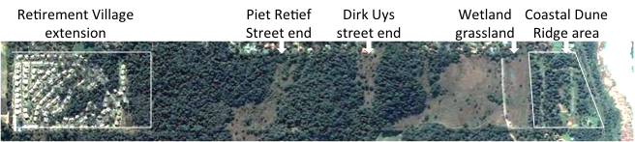
Figure 1. Current state of part of the original farm Aliceville 2147 south of the town Pennington. To the left (western end) is the development on the portion with the former eucalypt stand that was sold for extension to the Hibiscus Retirement Village. To the right (eastern end) is the coastal dune ridge with the invasive alien plants removed and with building the access road.

In response to a suggestion by Mr Wiseman Rozani of the Department of Agriculture, Forestry & Fisheries (DAFF) to assess the proposed changed layout of proposed developments at Umdoni Point, I arranged with Mr Chris le Sueur, developer of Umdoni Point, to visit the site on Thursday 15 May 2014. I was accompanied by Ms Pippa la Cock of Environmental Solutions, Port Shepstone, an independent environmental consultant guiding the developments. She provided me with the changed layout plan. We visited the eastern coastal dune ridge and the Retirement Village development at the western end of the original property, and discussed various issues around the changed development plans.

This report provides my assessment of the proposed changed development plan with recommendations for adjustment to the proposed changed development in terms of minimizing environmental and aesthetic impacts.

CHANGED DEVELOPMENT PLAN

The land tenure of the development changed from the former individual ownership of plots for building houses to single ownership of the entire development (most likely Hibiscus Retirement Village) managed by the property management staff. The layout changed from relatively large units to much smaller units with an expansion of the original development footprint mainly into the grassland areas (Figure 2). The changes from the original approved plan to the new proposed plan are as follows:
- Sub area A (western inland end) has been sold and developed as extension to the existing Hibiscus Retirement Village;
- Sub areas B, C and D are the central portions with a total of 58 units approved and the new plan proposes respectively 73, 40 and 90 units plus a Care Centre, Administration offices, etc.
- Sub area E is the eastern coastal portion with 32 units approved and the new plan proposes 88 units.

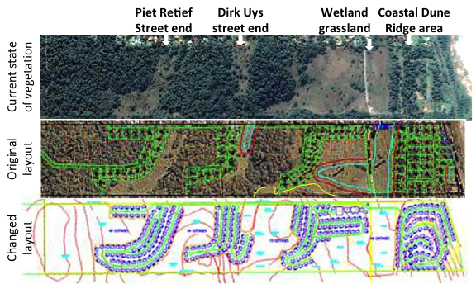
Figure 2. A comparison of the current development status (top, part of Figure 1), the original layout (middle) and the proposed changed layout with much smaller and many more housing units.

The original certificate of approval allowed a coverage of 30% on a property of 1500 m², i.e. about 450 m². The size of the units of the new plan ranges from 120 m² to 160 m², apparently plus a garage area of about 25m². Type A houses will have three bedrooms, Type B houses will have two bedrooms and Type C houses will have one bedroom. The allowable height was two storeys, and even if this also applied to sub area E (coastal dune ridge), the RoD did not allow two storey house units for this area.

The RoD specification that the service road should run along the northern boundary, even though it is through the forest, apparently still holds.

EVALUATION OF PROPOSED CHANGES IN LAYOUT PLAN WITH RECOMMENDATIONS

The evaluation is presented in numbered paragraphs for easier reference and considers the principles and guidelines presented in Geldenhuys (2005):
- In general the smaller units with assumed only single-storey houses will allow for better placement of house units amongst the existing trees where the units fall within the natural forest ecotones. The location of each unit should not be fixed but be placed with consideration of the existing indigenous trees on the approximate site. We follow the same principle in other areas of resort development within natural forests.
- The expansion in Sub areas B, C and D is mostly into the existing grasslands. In my view this is acceptable because even if no houses are built, it is not feasible to maintain healthy diverse grassland without fire management. Proper fire management is not possible in such areas, except in the main wetland area on both sides of the road leading to the golf course, and evoke severe criticism from the people in Pennington.
- The main concern of the proposed changes is the number of 88 planned units within Sub area E (coastal dune ridge). This number is almost three times the original number of 32. A more realistic number of units for this area is a maximum of 60. This would allow a better placement of the houses amongst existing trees (see point 1) and would minimize excavation impacts on the steeper seaward slope (Figure 3). It is expected that the proposed number of 88 units would lead to this area looking like the extended retirement village on the original area A (Figure 4). The number of house units in the extended retirement village area is about the same as what has been proposed for this coastal dune ridge area, but on a much larger area than the dune ridge area (see Figure 1). This would expose the seaward side of the coastal ridge with no recovery of the dune forest vegetation and will impact on the aesthetic appearance of this coastal dune ridge. In my view the environmental objective for this area should be to recover the natural forest as best as possible towards a forest appearance from the seaward side. If the reduced number of houses reduces the cost-efficiency of the new layout, then additional units could be placed along the southern boundary of the wetland area with the golf course property, as indicated with a yellow line on the original layout in Figure 2.
- It seems that the concept of using only indigenous species in the landscaping around the house units within the extended retirement village area has been ignored. Guidelines on the use of only indigenous species within the housing areas within Sub areas B to E should be enforced.
- The specification of the RoD that the service road for the proposed development should be placed along the northern boundary of the property should be reviewed. This route would cut through the natural forest in several places, and would aesthetically be unacceptable. It would be much more practical, aesthetical and possibly also cost-effective to follow the contours and forest ecotone areas for the location of the service road between the different development areas.

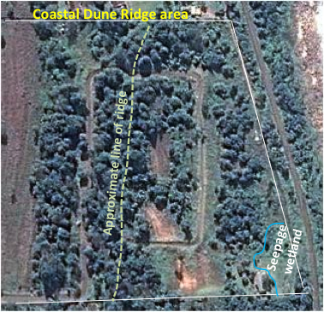
Figure 3. The current state of the remaining forest stands and trees on the coastal dune ridge (Sub area E) after removal of the invasive alien vegetation, die-back of some indigenous trees in the process, and building of the service road.

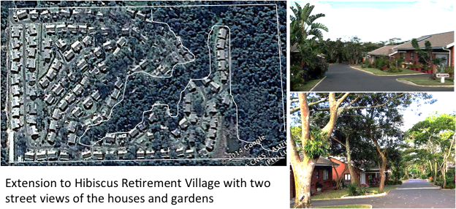
Figure 4. (a, left): The high density of house units within the extension of the Hibiscus Retirement Village into the former Sub area A; (b, top right): The high density of houses allow little room for tree growth, and many of the gardens seemingly have a large number of introduced plant species; (c, bottom right): Some indigenous trees that were present amongst the eucalypt trees, were retained and provide for a more aesthetic landscape within the new part of the retirement village.

ACKNOWLEDGEMENTS

I acknowledge with thanks the effort on short notice that Ms Pippa la Cock made to accompany me to the site, for providing me with information on the proposed changed developments, and for the useful discussions on the issues. If I have interpreted or presented the proposed changes wrongly, then this would ne entirely my fault.

REFERENCE

Geldenhuys, C.J. 2005. Assessment of the environmental Impacts associated with the proposed residential development on the remainder of the farm Aliceville 2147, Pennington, KwaZulu-Natal. Report FW-08/05, FORESTWOOD cc, Pretoria. 33 pp.

